

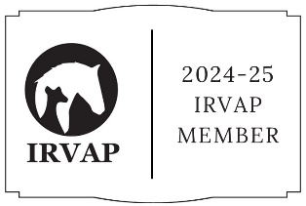

Veterinary Referral Form – Veterinary Physiotherapy
Please return the completed form to: emma@the-biomechanic.co.uk
Animal Details
Name:
Age:
Sex:
Breed:
Colour:
Insurance company:
Vaccinated: Y/N

Client Details
Full name:
Address of patient:
Home phone:
Mobile:
Email:
Preferred method of contact:

Veterinary Practice Details
Practice name:
Referring veterinary surgeon:
Address:
Telephone:
Email:

General Health Details (if applicable)
Weight | General Condition
Respiration | Pulse
Ears | Eyes
Skin/Coat | Temperament

Case History
(Please send vet history via email (emma@the-biomechanic.co.uk) if required)
Current Problem / Reason for referral

Investigations & findings

Pre-existing conditions

Current medication

Any specific requirements of Veterinary Physiotherapy
(Advised techniques and special patient requirements)

Declaration
This animal is a patient under my care and has received a full medical health check and examination and is in my opinion fit to receive veterinary physiotherapy treatment and/or aquatic therapy. I authorise physiotherapy and/or aquatic therapy for my patient to be carried out by Emma Newman-Teague (The Biomechanic) Veterinary Physiotherapist.
Signed | Date
 | Print Name

Practice Stamp

Following initial assessment, a vet report will be sent to you via email as well as any changes throughout the course of treatment. Please provide a preferred email address:
Email:

